Year 12 3CD Mathematics Specialist Term 2, 2010


Test 4
(Matrices, Exponentials and Logarithms, Functions)

This assessment contributes 5% towards the final year mark.

Name : Score :
(out of 45)

Part A The use of a CAS calculator is assumed.
(12 minutes permitted)

Do NOT turn over this page until you are instructed to do so.

1. A native reptile of MathMagic Isle called the hypottentot has a generation change every 2 years. The table below shows the survival rates, breeding rates and the initial population profile for 5 of the age groups :

Age (years) | 0-2 | 2-4 | 4-6 | 6-8 | 8-10
Survival Rate | 0.6 | 0.8 | 0.7 | 0.4 | 0
Breeding Rate | 0.1 | 0.9 | 1.4 | 0.5 | 0.4
Initial Population | 10 | 12 | 15 | 20 | 10

a. State the Leslie matrix L for this colony of hypottentots.

[2]

b. Use matrix L to determine the population profile after 10 years.

[3]

c. Determine the long term inter-generational growth rate, as a percentage.

[3]

2. The graph of function f(x) = 0.5(x + 2)(x – 3) is shown below.

Region A is bounded by the curve, the x axis, and the lines x = 0 and x = 3.
Region B is bounded by the curve, the x axis, and the lines x = 3 and x = a.
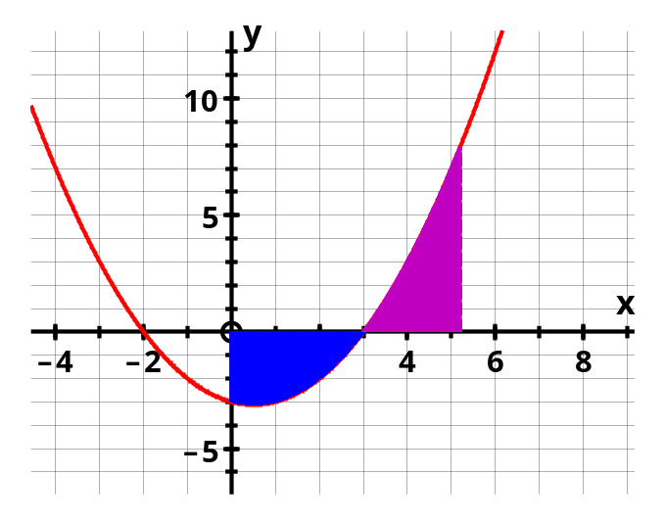

If the areas of regions A and B have the same area, determine the value of the constant a correct to 0.001.

[4]
This page has been left blank intentionally.
It may be used for spare working.

Year 12 3CD Mathematics Specialist Term 2, 2010

Test 4
(Matrices, Exponentials and Logarithms, Functions)

This assessment contributes 5% towards the final year mark.

Part B No calculator to be used.
(33 minutes permitted)

Name :

Do NOT turn over this page until you are instructed to do so.

3. Consider the following transformation matrices in the co-ordinate plane :

R rotates 180º about the origin
D dilates vertically about y = 0 with factor 1.5
S downward shear parallel to the vertical axis with factor 1

a. Give matrices R, D and S.

[3]

The 3 diagrams below show a parallelogram.
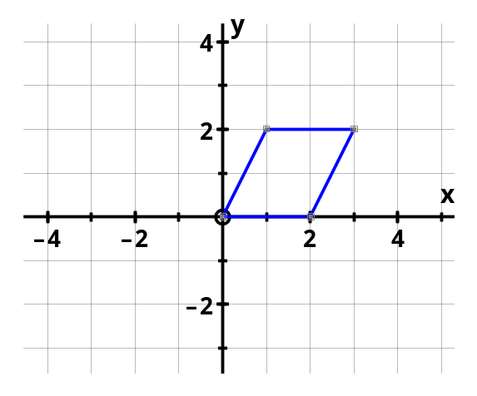

Diagram 1 Diagram 2

Draw the image of this parallelogram under the action of transformation :

b. D (on Diagram 1)
[1]
c. S (on Diagram 2)
[2]
d. R then S (on Diagram 3)
[2]

Diagram 3

3. e. Does transformation matrix S change the area of any object it transforms ?
Explain.

[2]

f. If the parallelogram is transformed by matrix D then S, what matrix will return the resultant image back to the original parallelogram ?

[3]

See next page
4. Find the following indefinite integrals, using an appropriate Calculus technique :
[ONE mark will be given for a correct answer only]

a. 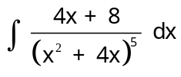

[3]

b. 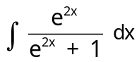

[3]

c. 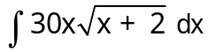 Put u = x + 2

[4]
5. Evaluate the following definite integrals, using the given substitution and an anti- derivative technique : [ONE mark will be given for a correct answer only]

a. 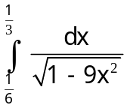 Put 3x = cos θ

[4]

5. b. Given that 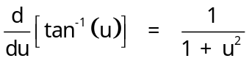 evaluate 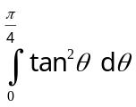 by using u = tan θ.

[6]

End of Assessment Task

This page has been left blank intentionally.
It may be used for spare working.

This page has been left blank intentionally.
It may be used for spare working.

